Outputs for Q2)A)

Q2) a)

1. Sum of Digits of a number

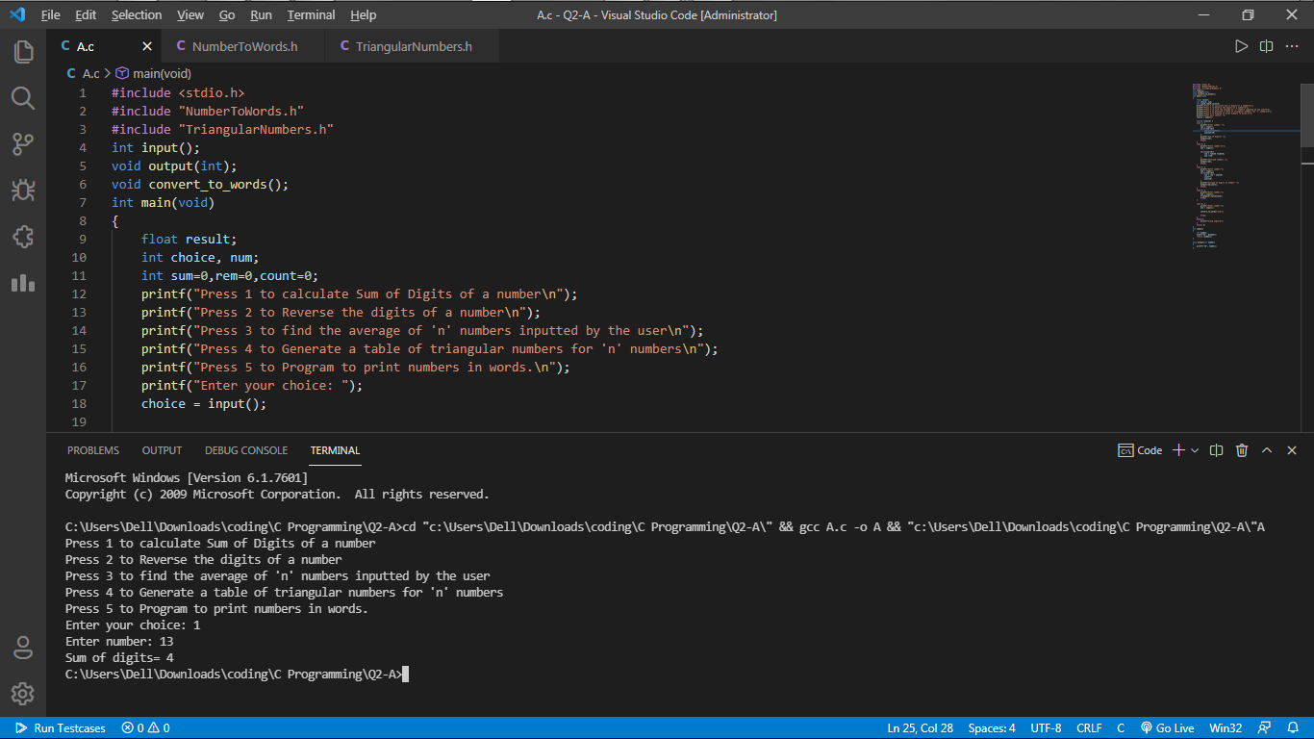

b) Reverse the digits of a number

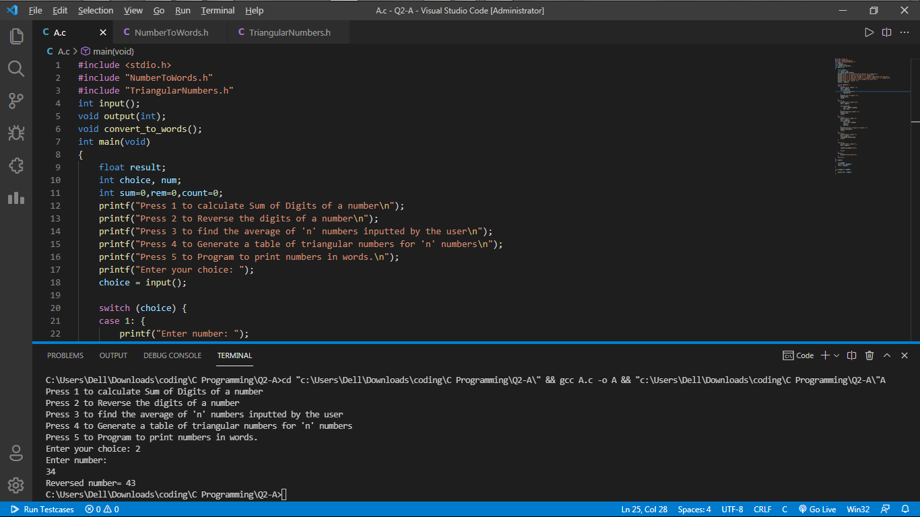

c) Average of ‘n’ numbers inputted by the user

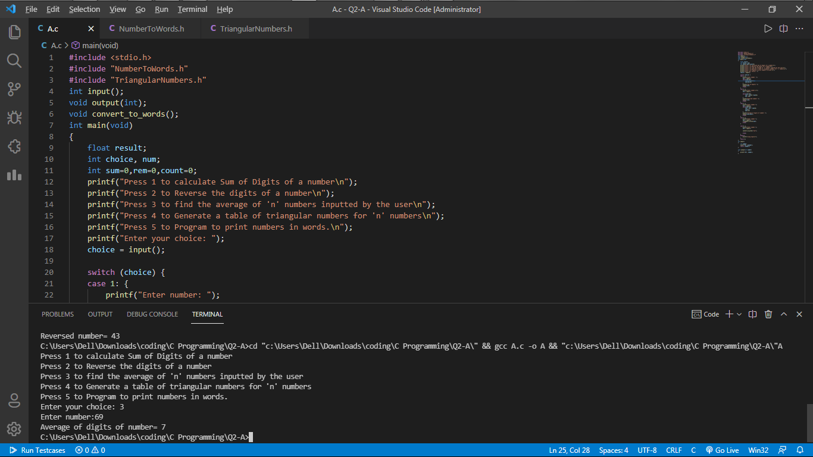

d) Generate a table of triangular numbers for ‘n numbers.

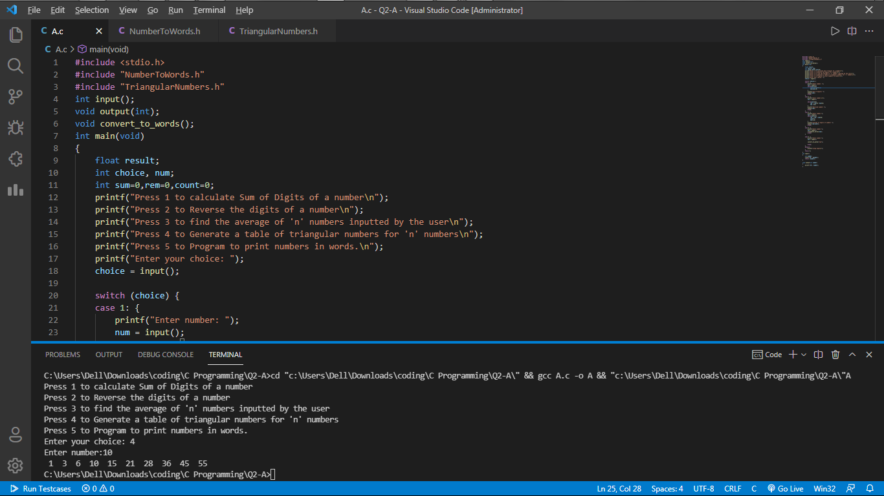

e) Program to print numbers in words

